**Concept Document**

**Production Team:**

QA: James Lee

Programmer: Jason Kaufman

Designer/Programmer: Justen Minamitani

Artist: Kathleen Phan

Audio: Garett Nguyen

Project Manager/Designer: Matthew Haddad

**Target Audience:**

Age Range: 10-20 Men/Women

**Game Genre:**  
Rogue-like Party board JRPG

**Target Platform:**

PC

**Game Story:**

This game is settled in a world that uses sugar/candy as an energy resource and recently trolls have been eating up their resources.

The “players” gather up from different areas of the world (defining why they have different starting points) to defeat the monster and take back their energy source.

A) Game board

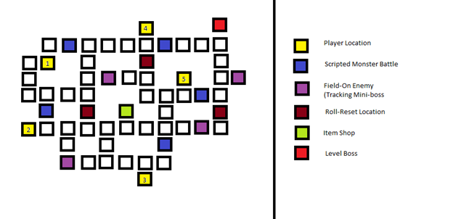

Players start at the yellow locales and can move a set amount each turn with a limit per turn.

Ideal setup for characters:

1. Damage

2. Healer

3. Damage

4. Healer

5. Tank

However, it may be up to the player to choose his locations and classes.

Scripted Monster battles, marked in blue, are relatively simple monster battles. Each Character may be equipped to fight monsters over another, but some excel at doing so. Healers and Tanks may take a while to fight anything alone.

**Field-On Enemies** are tracking super-enemies that are not ideal to fight alone. It is best to have at least three members to take one out efficiently, although a group of two can feasibly take one down. Four or Five members guarantees a swift victory. These enemies only begin to follow the player once the player enters their line of sight on the board and take one step per player step.

Roll Reset locations increase the number of rolls a character who passes by it can take. The character may even be able to transfer increased amount of steps to another character.

Item shop gives any character an upgraded version of their current weapon, making them more efficient at taking on scripted monsters, Field On Enemies, and if all players have their upgraded weapons, fighting the Level Boss should be fairly simple.

Level Boss should only be taken on with at least 4 characters in the party. It has about 3 times amount of health as a FOE, and about 25% more damage output.

B) Battle System

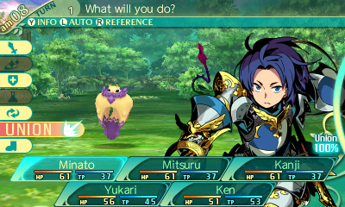

A standard JRPG System. However, scripted monster battles only have one monster that needs to be fought, as opposed to a horde of monsters. Skills can be chosen by the character to be given as per class. They should be relatively simple skills, because there is not much time on the board to be working out a complex skill system or level up system.

The player’s power level is determined by his or her level. The level starts out at 1 and maxes out at 10. Each Monster battle increases the level by 1, defeating a Field-On Enemy Increases the level by 2, and every turn the player has completed without dying, the player’s level increases by 1/3. This rewards the player for not rushing to the end so quickly, and sometimes conserving rolls.

At levels 3, 5, 7, and 10, a player can gain new skills to make them stronger.

D) Items

Players start off with a simple item that allows them to perform their role, and a little bit of other roles, somewhat effectively. For example, a swordsman may carry just a sword, but have a small shield for defending a teammate. Mages carry a staff that is great for attacking, but has minimal healing capabilities.

Items bought at the shop are accumulated through gaining money, which is given for killing Field-On Enemies, Monsters, as well as surviving a turn. Typically, there will be 3 iterations of an item, the best being the most expensive.

E) Classes

Classes fall into three categories: Offense, Defense, and Support.

Offensive Classes might contain:

* Swordsman, Cavalryman, Mages, Rogues, etc

Defense:

* Warders, Dragoons, etc

Support:

* Shamans, Medics, etc

**Part B) Gameplay**

Every turn is counted. Every turn, a player will be able to choose his amount to move, or he can choose not to move at all. He may transfer his moves to another player but gains no EXP or money if he chooses to do so.

A player can also choose which direction to move if a path is forked or looping, so he can best optimize a path to his fellow teammates. Field-On Enemies also punish sedentary players, as they will move at least once per turn when they have spotted a player in their line of sight. When all players have moved in one turn, the turn ends and a slight healing, a chance at getting a single use item, and money is distributed.